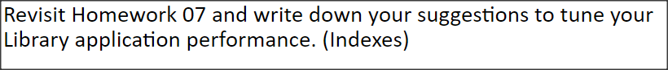

Indexes that will help improving my library application performance:

1. Create index with key = SBN to speed up searching books using ISBN

db.books.createIndex({isbn:1})

1. Create index with key = author to speed up searching books using author name

db.books.createIndex({author:1})

1. Create index with key status to speed up searching borrowed books or available books.

db.books.createIndex({status:1})

1. Create compound index with keys are author and status to speed up searching books owned by particular author that is available.

db.books.createIndex({author:1,status:1 })

**Homework 07:**

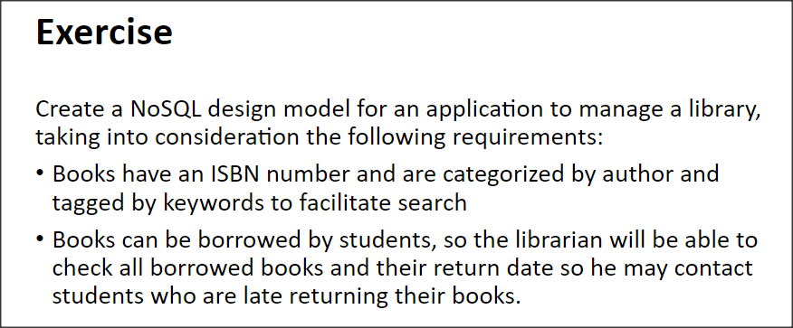

{

_id : objectId(),

isbn: '1234567',

author: 'author1',

tags: ['tag1', 'tag2', ...],

status: 'available / not available',

last_return_date: ,

last_borrow_date: ,

last_borrowedBy_studentName: 'student1',

last_borrowedBy_emailAddress: 'student1@mum.edu',

hists: [

{

borrow_date: ,

return_date: ,

student_name: 'student1',

student_emailAddress: 'student1@mum.edu'

},

{

borrow_date: ,

return_date: ,

student_name: 'student2',

student_emailAddress: 'student2@mum.edu'

},

{

borrow_date: ,

return_date: ,

student_name: 'student1',

student_emailAddress: 'student1@mum.edu'

}

]

}